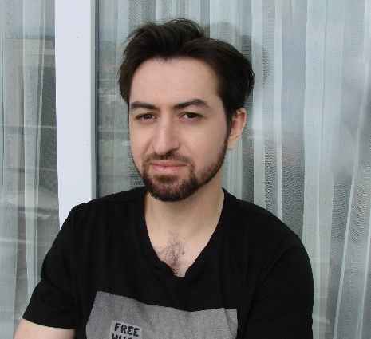Sergey Dalmatkin

# Objective

Video Editor and Motion Designer

# Personal profile

Video editor and motion designer with 10+ years of experience in video production, news broadcast, commercials, digital Ads, social media platforms.

Solid expertise in post-production, color correction, compilation, and visual effects application.

Detail-oriented and extremely strict with deadlines.

Contact me

### Whatapp:

[+995591064685](https://wa.me/995591064685)

### Email:

[s.dalmatkin@gmail,com](mailto:s.dalmatkin@gmail,com)

Website:

[Dalmatkin.com](http://www.dalmatkin.com)

## Skills Summary

* Advanced editing and motion design
* Managing live streams
* Keeping with the latest media techniques and trends
* Social media formats: Promo videos, Instagram, Youtube, Facebook Ads etc.
* Fast working speed
* Punctuality

## Technical

* Adobe Premiere, After Effects (plugins and scripts)
* Photoshop
* Audition
* AVID
* Final cut

## Additional info

Languages:

* English - Fluent
* Hebrew - Fluent
* Russian - Native

### ShowReel:

<https://www.youtube.com/watch?v=pqWQBVSLb30&ab_channel=SerjiDalmatkin>

# **Feedback on Upwork:** <https://www.upwork.com/freelancers/~01b6814edec6889465>

# Work Experience

### STV News, YouTube channel (500k+) | March 2020 – Present Video Editor, Motion Designer

* Edit up to 20 news stories for daily live broadcast
* Search and assembly video content for the channel’s daily shows
* Create original 2D animation for the channel’s weekly show
* Everyday work with the creative team (Producers, reporters and showrunners)
* Designed motion graphics and style templates for the channel (animation of intros pre-rolls titles, etc)  
  - Fact checking and video research
* Performed over 200 successful YouTube broadcasts

### Freelancer | 2018 - 2020 Video Editor, Motion Designer

* Created over 200+ successful projects
* Cooperation with international companies and private clients around the world
* Creation of educational videos, tutorials, explainers and commercials

### Neo-Graphics studio| 2017 – 2018 Video Editor, Motion Designer

* Animation for advertising in After Effects from scratch
* Creating explainer videos
* Infographic videos and compositing
* Color correction of edited footage

### 

### VideoBaker studio| 2016 – 2017

**Video editor, Motion Designer**

* Shape animation for promotional clips
* Editing of advertising videos
* Infographic videos and compositing
* Assistance on the set
* Creation of special effects

### Your movie studio| 2015 – 2016 Video editor

* Editing holiday and event videos
* Color correction
* Post-production

# Education

### Higher Education

**Film school “Camera Obscura” – Tel-Aviv 2012-2015**

B.A. in Filmmaking